Continuation from yesterdays lesson.

Answer in your Interactive Notebook.

Explain – Invasive Species Cards
- What reasons do you have for allowing the eradication of some species and not others?
- Why is the choice difficult?
- How do you feel about hunting expeditions for all invasive animal species? Explain your reasoning.

Read the following Podcast and

answer the questions that follow.

WGCU Podcast Transcript
Biologists Remove Invasive Tegu Lizard, Threatening Florida's Wildlife
Topher Forhecz, WGCU
October 2, 2015
Listen to the podcast (5:24) at http://news.wgcu.org/post/biologists-remove-invasive-tegu-lizardthreatening-floridas-wildlife
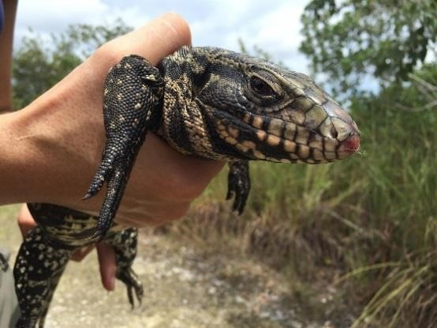
Credit: Topher Forhecz/WGCU
The Argentine black and white tegu is one of the newest, biggest threats to Florida’s natural wildlife. The large, invasive lizard was first noticed in the wild roughly 10 years ago. Now, it has two main breeding populations and biologists are trying to contain them. They want to stop tegus from becoming established throughout the state.
University of Florida wildlife biologists Kyle Allen and Lindsey Garner walked down a small path on state conservation land just south of Florida City in early September.
It’s basically the southern tip of Florida. Marshes and saw grass surrounded us for miles.
Garner led the line. She headed toward a foot-tall metal cage tucked away in the brush.

“We have a tegu,” she said.
Inside the cage, a two and half foot-long lizard thrashed back and forth.
They’re called black and white tegus, but this one has more yellow in between strips of jet black scales.
Tegus come from South America. They’re popular in the pet trade, which is how biologists think they ended up in the wild. They can get pretty big, up to five feet long - and they’re not picky eaters.
Garner listed some of the tegus’ diet: "Snakes, other lizards, cocoplums, fruit, vegetables, small mammals,” she said.
Garner and Allen are part of a federal, state and local effort to control the tegu populations. One is in Miami-Dade County and the other is in Hillsborough County.
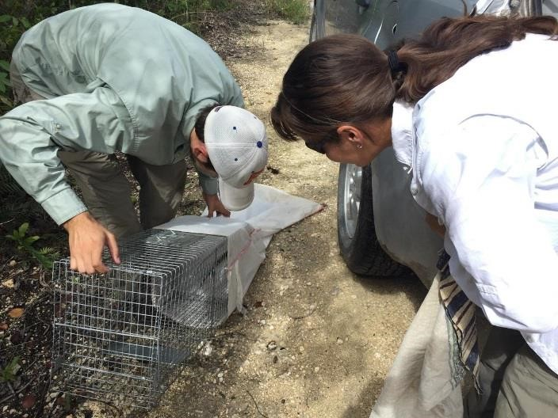
University of Florida biologists Kyle Allen and Lindsey Garner move a captured tegu into a bag. Biologists have captured more than 600 tegus this year.
Credit: Topher Forhecz/WGCU

Biologists have spent the last few years trying to learn more about this animal.
Especially how tegus live in Florida. Garner said they want to know how fast they grow and how long until they can reproduce.
“We don’t know too much from their native range and we definitely don't know a lot about what's going on here because they have a completely different set of conditions in the environment they have to contend with,” she said.
The team pulls out a bag from the back of the truck. They kneel on each side of the cage. They placed the bag over the opening of the trap.
“These tegus are very powerful creatures so sometimes they do make a straight run to the back of the bag and if the bag isn’t secure on the trap, it’ll just start taking off into the woods and you’ll have a loose bag,” Allen said.
But, this lizard slinks into the bag.
They write down some data, and put the bagged tegu into a bin in the back of the truck. “DANGEROUS REPTILES” is scrawled on the cover.
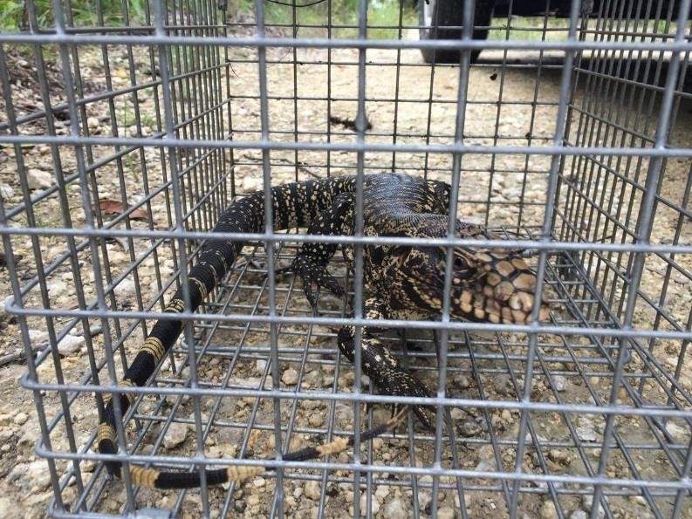
Credit: Topher Forhecz/WGCU
“We’ll take this animal bag to the lab and we’ll have one less tegu in the Everglades,” Garner said.
It’s just one part of a larger effort to figure out the tegus’ population size and range.
The traps give them some idea. Last year, state and federal partners caught 410 tegus. They stopped trapping this month (October). So far, they have caught more than 600 tegus (by the end of September).
Allen said they plan to increase their trapping efforts next year.
“If the number of tegus we remove stays the same then we're doing a good job, but if we double the number of tegus then we'll know that it's a bigger problem than we thought,” he said.
Scientists want to avoid what’s happened with Florida’s most famous invasive species: The Burmese python.
They say it will be next to impossible to rid the state of those large snakes.
But, tegus especially worry biologists because they do something pythons don’t. Tegus can do the reptilian version of hibernation, meaning they can survive in colder places.
“That's really scary because tegus not only have the potential to be a problem in South Florida in our subtropical climate, but they could also spread into temperate climates, much further north than we're seeing with the pythons so far,” she said.
Tegus are all over the state. There have been reported sightings as far North as Nassau County, as far west as Bay County, and across south Florida from the east to west coasts.
Jenny Ketterlin Eckles is a biologist with the Florida Fish and Wildlife Conservation Commission. FWC contracts UF for tegu work and studies.
She said staff catches about 30 each year from the Hillsborough population.
“So, the Hillsborough population is more spread-out among an upland ecosystem as opposed to in the Everglades where they’re concerted in the levees and canals, so it's been a lot harder to get a handle on what's going on with that population,” she said.
Ketterlin Eckles said they hope to do an assessment of that population next year.
Back south of Florida City, UF researchers Kyle Allen and Lindsey Garner are finishing up checking traps around a levee.
Garner worries about native Florida wildlife like the threatened American crocodile that nests at the Turkey Point nuclear power plant to the east. That’s because tegus love to eat eggs.
They euthanize the tegus they’ve captured and perform necropsies to learn more about them.
“The euthanizing part, it's the least favorite part of the job… but it's a necessary evil. There’s absolutely no other viable option,” she said.
Garner says the tegu population in South Florida feels sort of like a bomb. It’s ticking like the bomb that went off with the pythons and they could no longer be contained.
Garner and Allen hope to defuse this bomb before it threatens more of Florida’s wildlife.
Forhecz, T. (2015, Oct 2). Biologists Remove Invasive Tegu Lizard, Threatening Florida's Wildlife. Retrieved from http://news.wgcu.org/post/biologists-remove-invasive-tegu-lizard-threatening-floridas-wildlife.
Elaborate – Tegu Lizards Threatening Florida Wildlife
- Why do you think that Garner says that the tegu population in South Florida feels sort of like a ticking bomb?
- Do you agree that euthanizing the caught lizards is “a necessary evil?”

